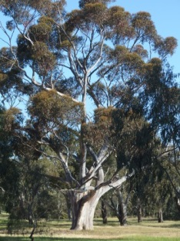 Community Planting

Royal Park Protection Group Invites you to

the next plantings in the Bayles Street Grasslands - Royal Park

When: Saturday August 19th 10am to 12 noon

There will be a planting in part of the Circle grasslands in Royal Park.
This is a further step in increasing the diversity in this special grassland area. It will complete the planting we had in June.

The plants we have this time are:
Wahlenbergia luteola Yellow-backed Bluebell

Rytidosperma duttonianum Brown Back Wallaby Grass

Rytidosperma caespitosum Common Wallaby Grass

Entry is from Gatehouse Street opposite Bayles Street.
Car parking is in Gatehouse Street and surrounds but is restricted so watch the signs. Parking time limits vary from 1 to 4 hours.
Equipment and morning tea provided.
BYO gardening gloves.
All welcome. Do invite your friends.

More information: Call Anne(RPPG) 0412279156
or Chris (Royal Park Officer) 0437925553.

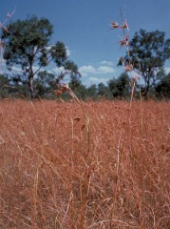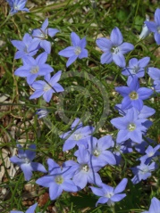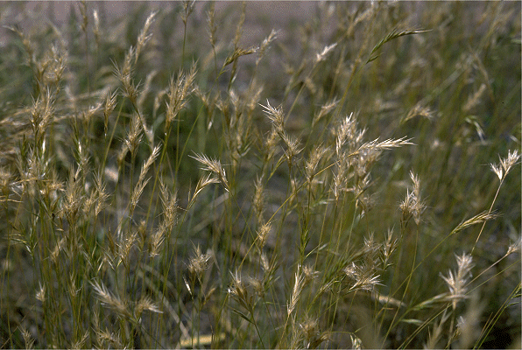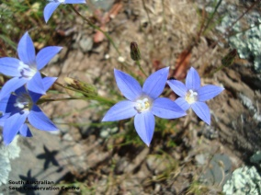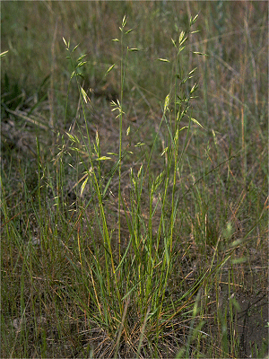
NOTE: THIS PLANTING WAS ORIGINALLY PLANNED FOR SEPTEMBER BUT HAS BEEN BROUGHT FORWARD.

